Title of the Extended Abstract
First Author¹ , Second Author^{2#}
¹ University of XYZ, City, Country
² Institute of XYX, City, Country
#Corresponding Author: abc@gmail.com
*Note: Please do NOT add author names, emails and affiliations for the initial manuscript.
The extended abstract should contain following sections. Please follow the formatting hints provided below.

- Introduction
- Materials/Methodology
- Results and Discussion

Section

A Subsection Sample
Please note that the first paragraph of a section or subsection is not indented. The first paragraphs that follows a table, figure, equation etc. does not have an indent, either.
Subsequent paragraphs, however, are indented.

Sample Heading (Third Level). Only two levels of headings should be numbered. Lower level headings remain unnumbered; they are formatted as run-in headings.

Sample Heading (Fourth Level). The contribution should contain no more than four levels of headings. The following Table 1 gives a summary of all heading levels.

Table 1. Table captions should be placed above the tables.
Heading level | Example | Font size and style
Title (centered) | Lecture Notes | 14 point, bold
1st-level heading | 1 Introduction | 12 point, bold
2nd-level heading | 2.1 Printing Area | 10 point, bold
3rd-level heading | Run-in Heading in Bold. Text follows | 10 point, bold
4th-level heading | Lowest Level Heading. Text follows | 10 point, italic

Displayed equations are centered and set on a separate line.

$a + b = c$ (1)

Please try to avoid rasterized images for line-art diagrams and schemas; whenever possible, use vector graphics. The minimum resolution for all images is 300 dpi. For graphs, the axes must be labelled with the variable; SI units must be used and depicted in brackets (see Fig. 1).

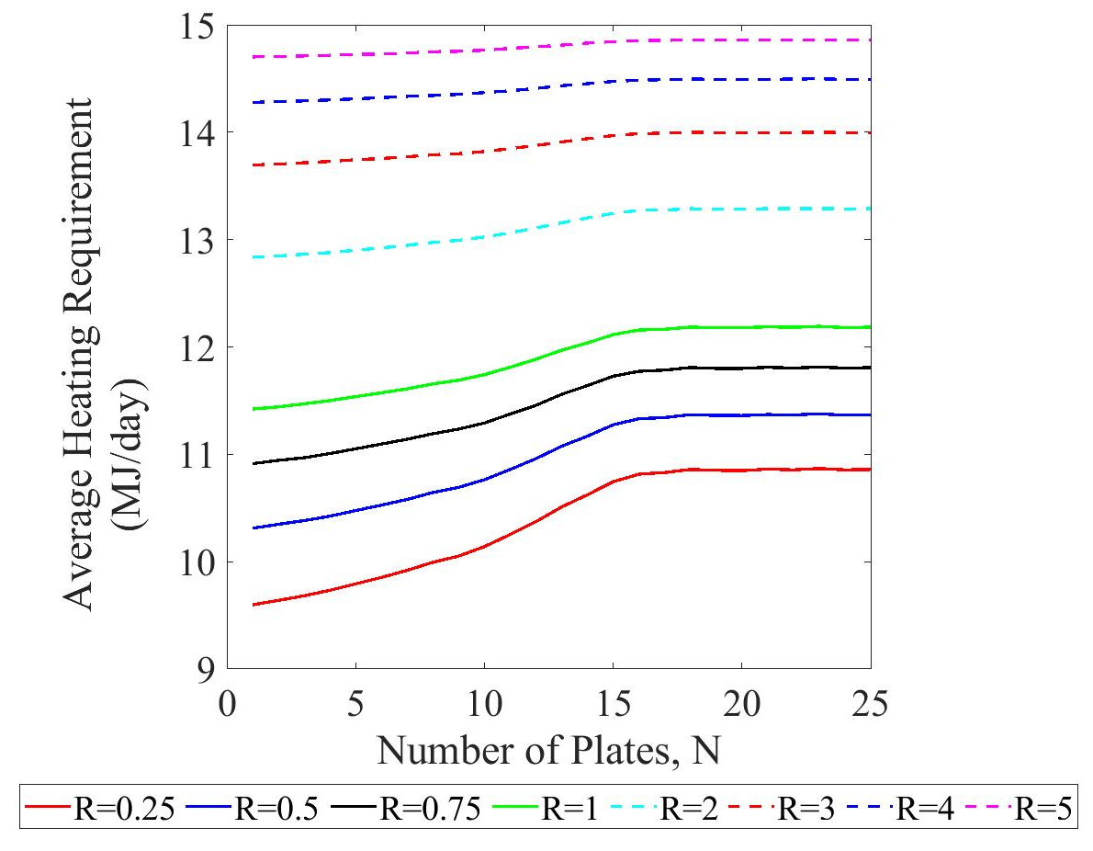
Fig. 1. A figure caption is always placed below the illustration. Short captions are centered, while long ones are justified. The macro button chooses the correct format automatically.
For citations and referencing, please use a reference manager software; Mendeley is preferred. For in-text citations, we prefer the use of square brackets and consecutive numbers; citations using labels or the author/year convention are also acceptable. The following bibliography provides a sample reference list with entries for journal articles [1], conference proceedings [2], a book [3], proceedings without editors [4], as well as a URL [5].

Conclusion
Conclusion of the extended abstract, not exceeding 150 words.
Keywords: First Keyword, Second Keyword,.. (Maximum of five keywords)

References
- Author, F.: Article title. Journal 2(5), 99–110 (2016).
- Author, F., Author, S.: Title of a proceedings paper. In: Editor, F., Editor, S. (eds.) CONFERENCE 2016, Name of magazine or book series under which the proceedings are published, vol. 9999, pp. 1–13. Publisher, Location (2016).
- Author, F., Author, S., Author, T.: Book title. 2nd edn. Publisher, Location (1999).
- Author, F.: Contribution title. In: 9th International Proceedings on Proceedings, pp. 1–2. Publisher, Location (2010).
- Homepage, http://www.url.com, last accessed 2016/11/21.

